NAME: AKSHAT KUMAR MISHRA

Class: DevOps, 2021

Sap ID: 500076758

Subject: Build and Release Management Lab

EXPERIMENT 1:

Aim: First Maven Project:

Step 1: Go to create a new maven project.

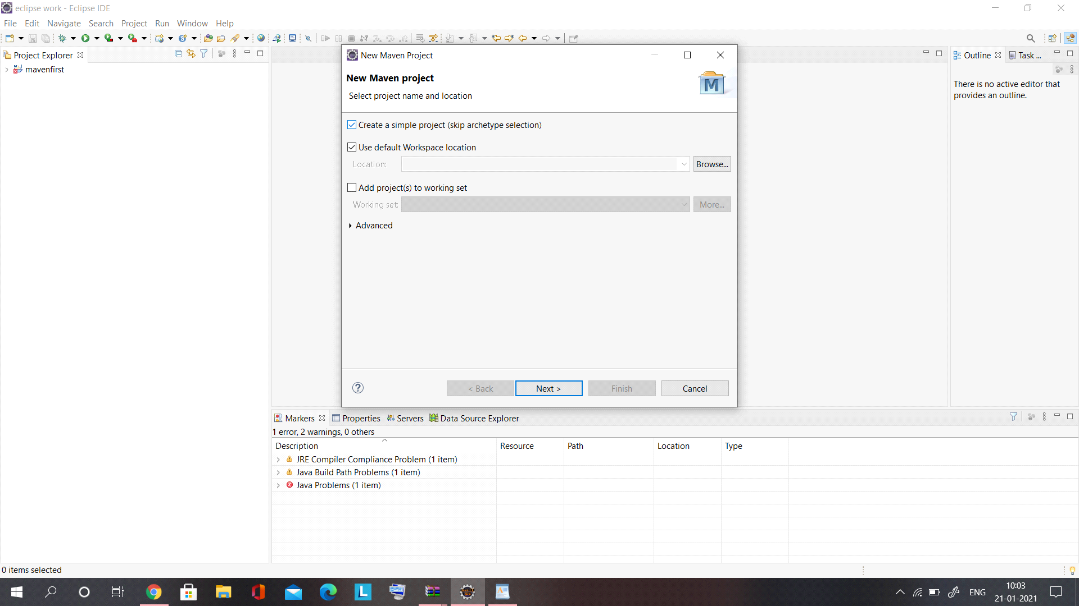

Step 2: Give the artifact and group id.

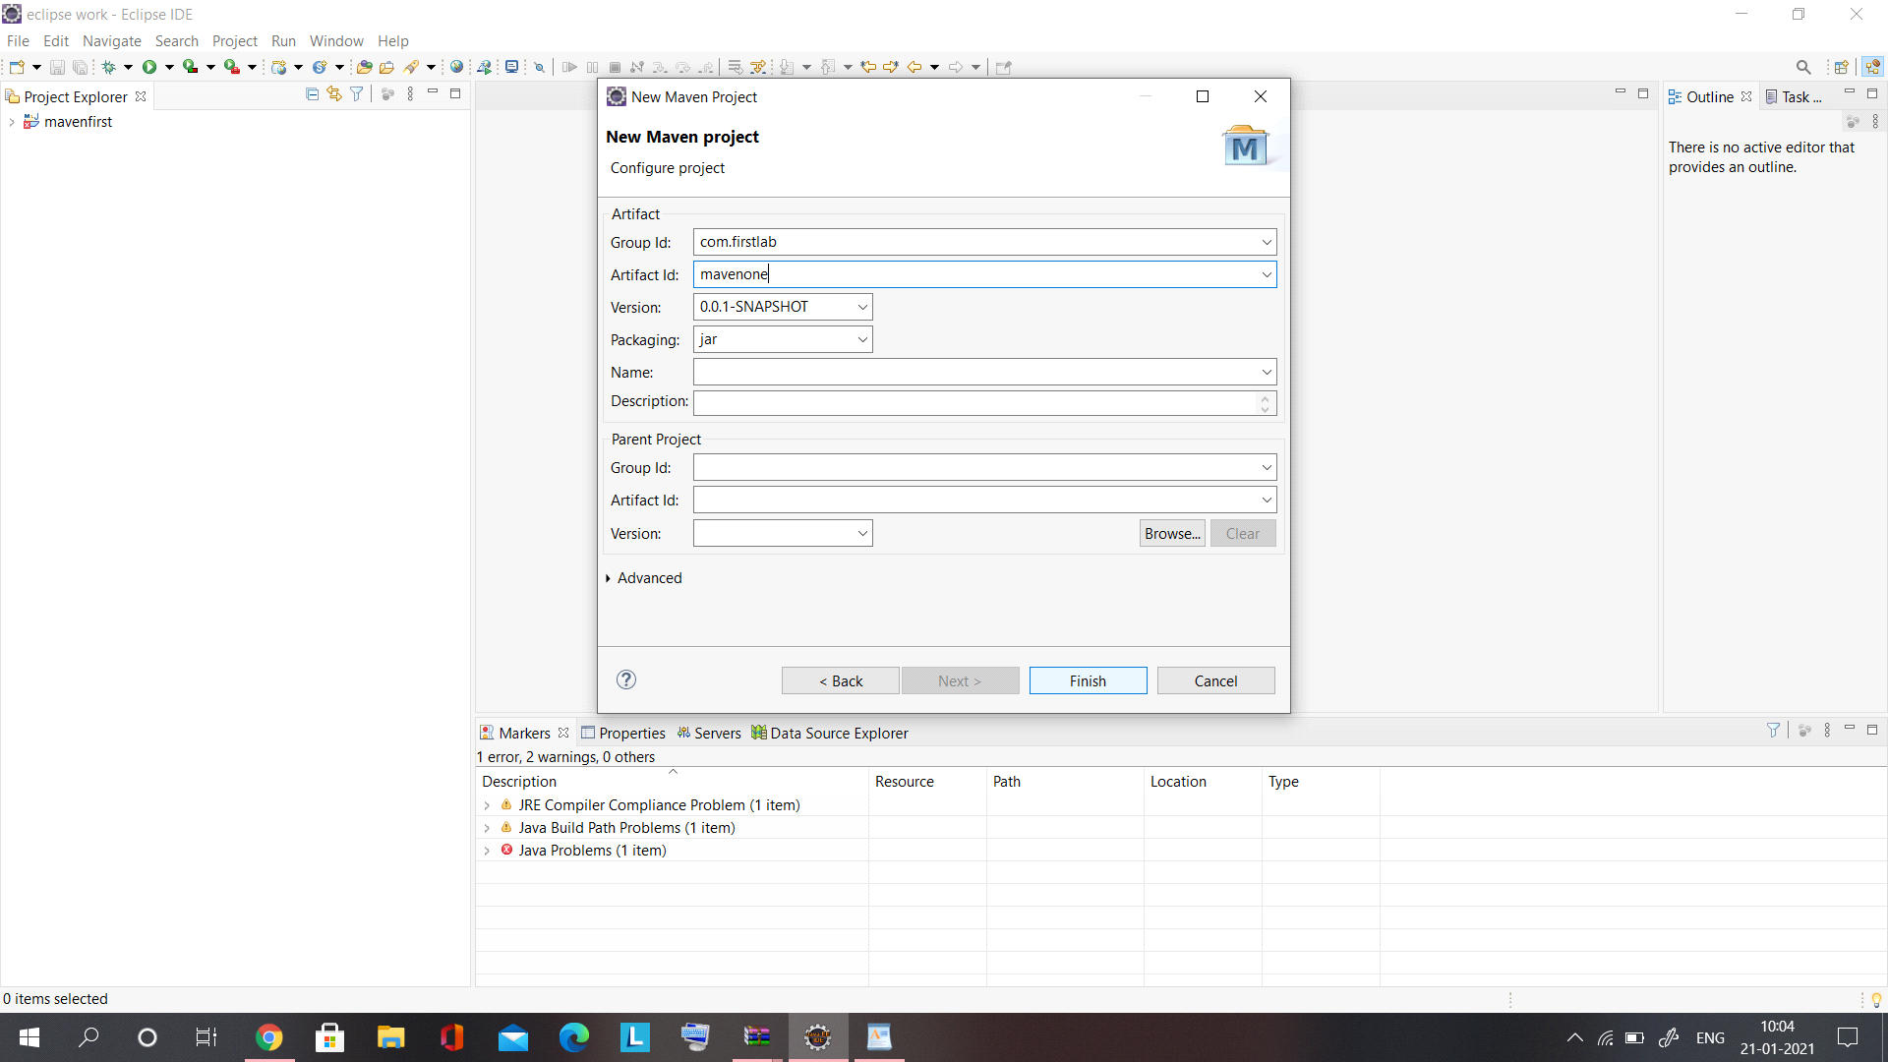

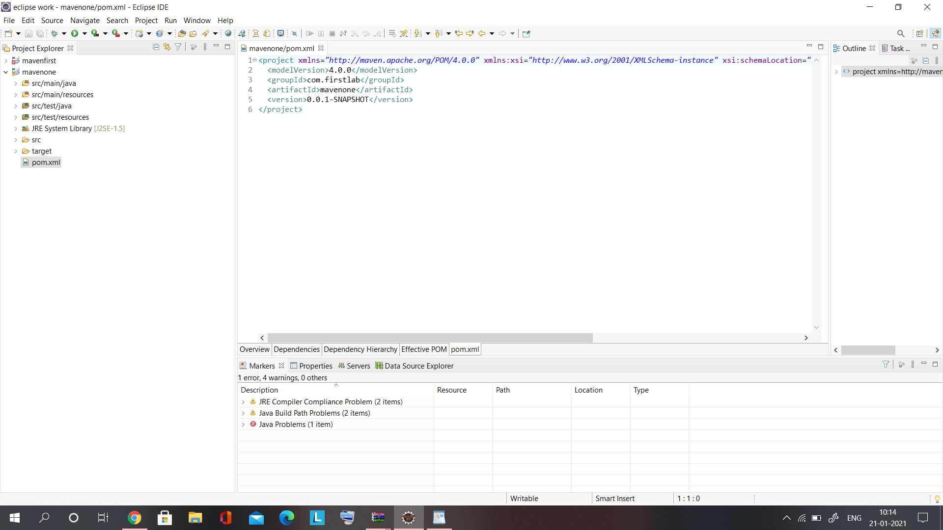

Step 3: Download the dependencies.

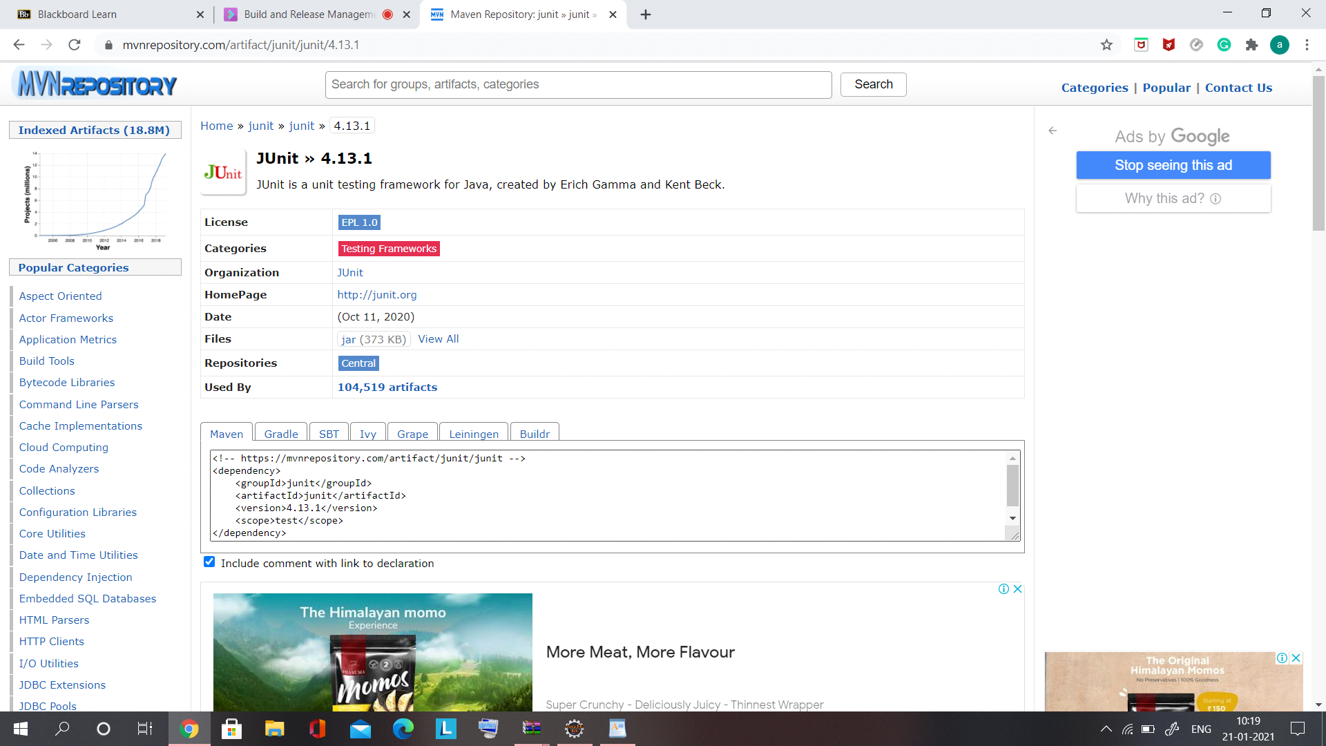

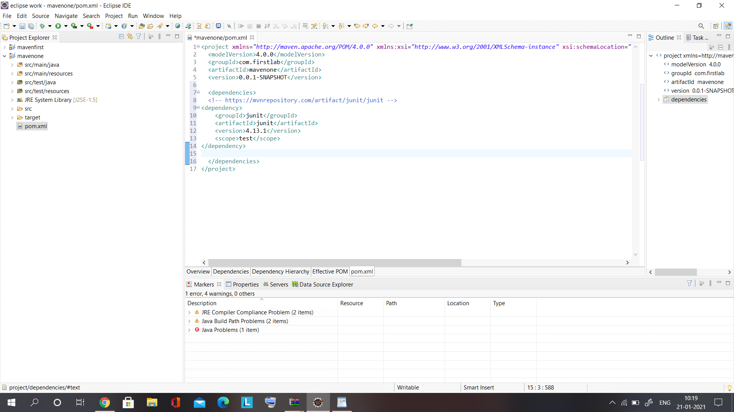

now, i started to create my first program for testing by the junit dependencies.

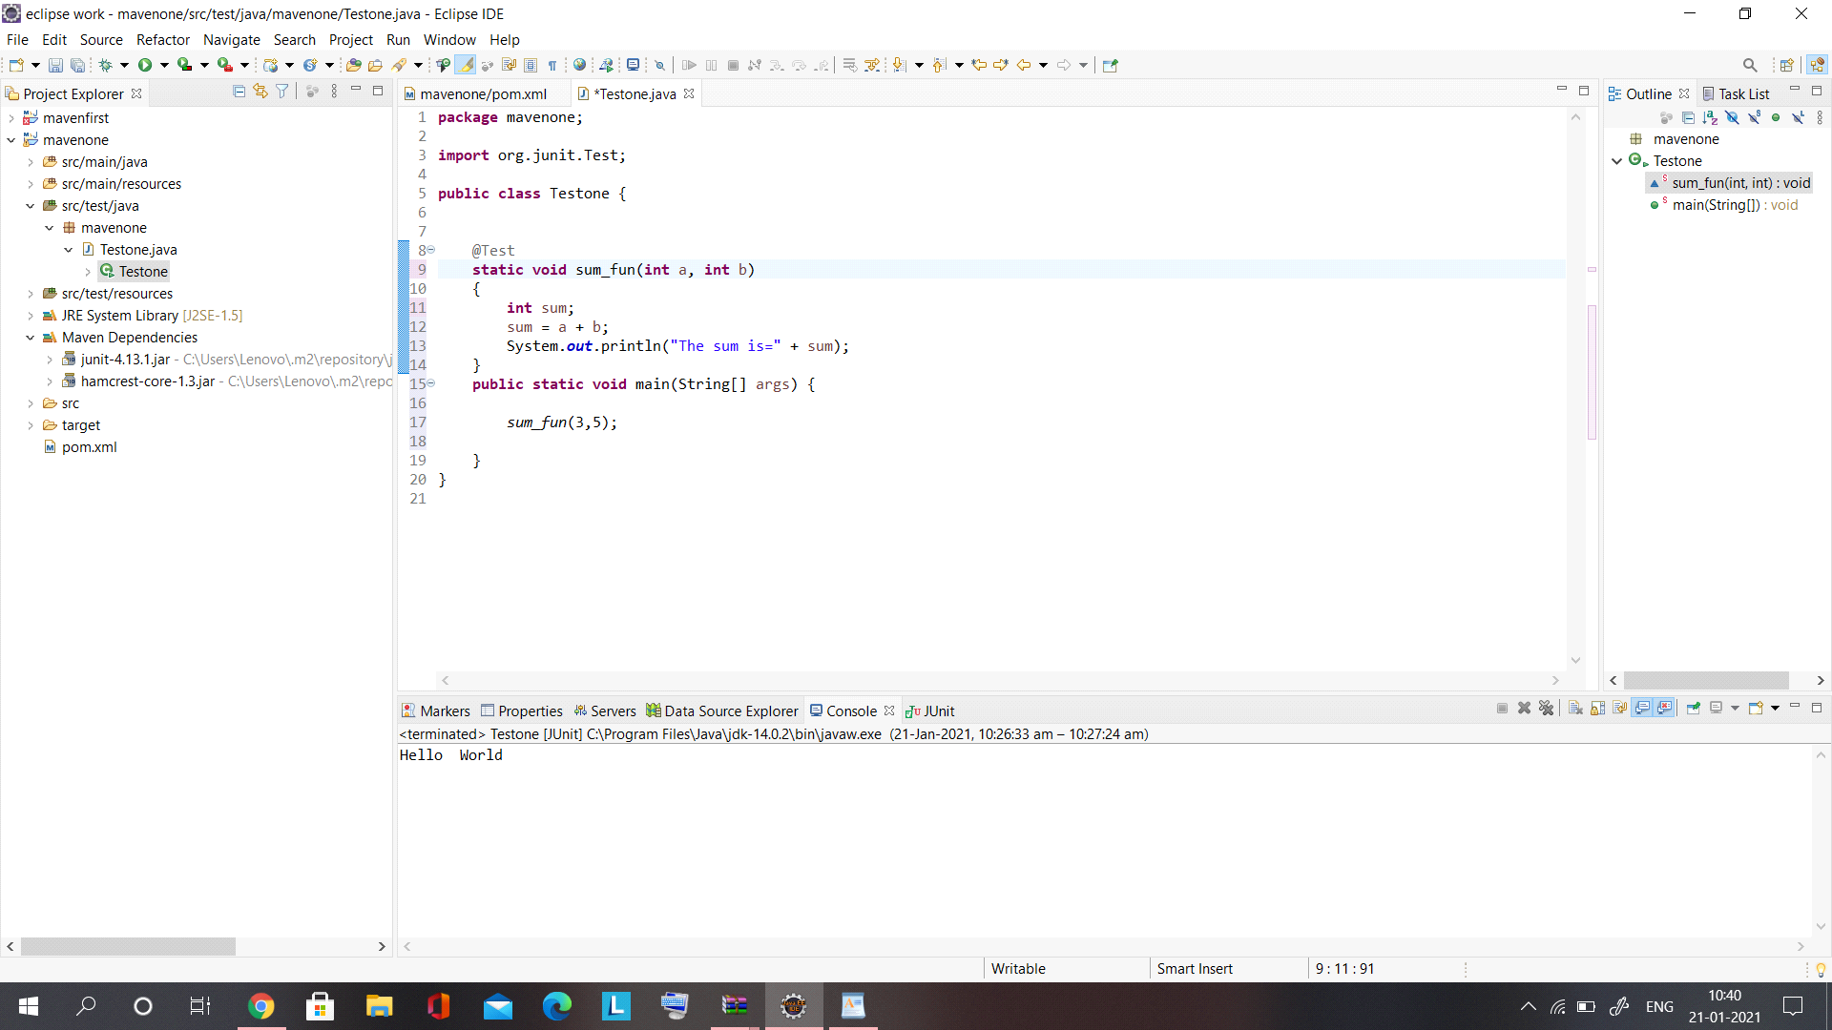

The program output is as above